Mixology From Home
Griffin Witt, Louie Finder, Ryan Grant, Timur Bashpanov
Point of contact email addresses: gwitt1@vt.edu, louiefinder@vt.edu, ryangrant@vt.edu, timur23@vt.edu
CS 4604, Dr. Nizamani
Spring 2026

Contents
1. Last Submitted ER diagram 3
2. Updated ER Diagram 4
2.1. ER diagram of logical database design 4
2.2. Details of the alterations 4
3. Relational Schema Diagram 5
4. Roles of Project Members 6

Last Submitted ER diagram

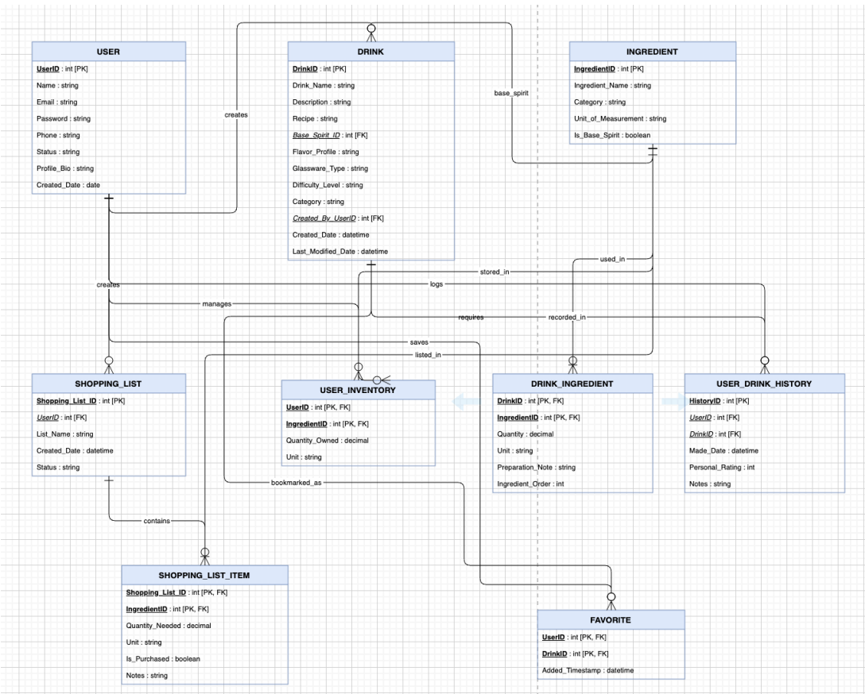

Updated ER Diagram
Conversion of conceptual ER diagram into logical ER diagram

ER diagram of logical database design
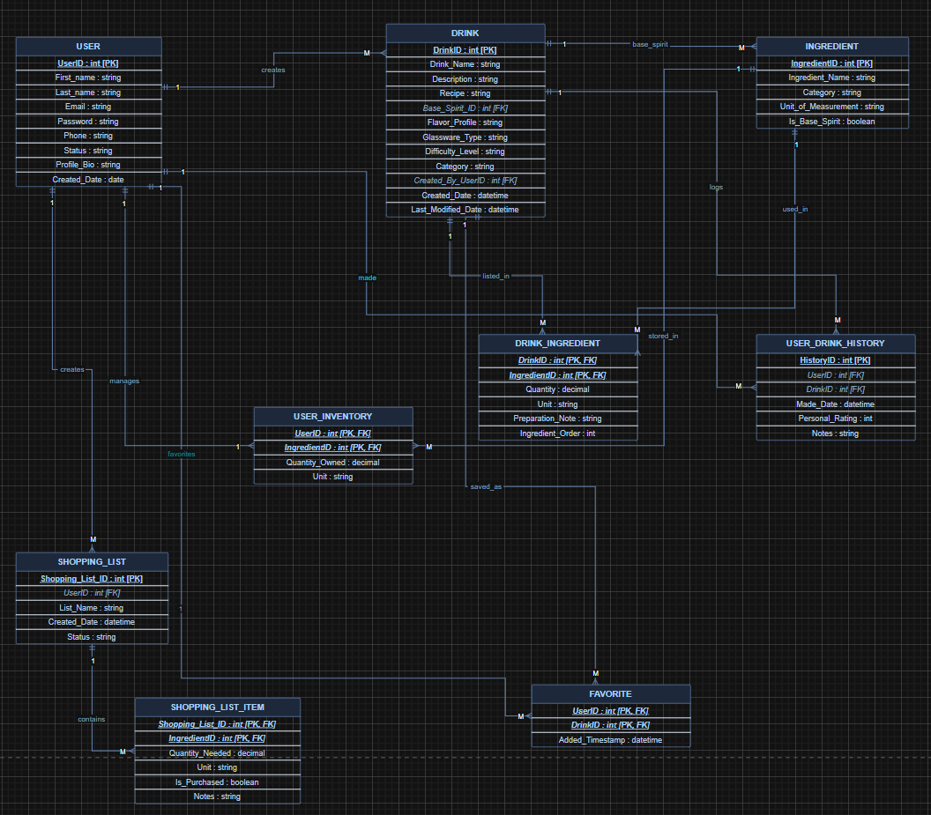

Details of the alterations
[instruction]
Please provide precise details of the alterations made to the design. Clearly explain what was changed or refined (e.g., relationship cardinalities, weak entities, multivalued attributes, associative entities). Justify these changes based on the database design rules discussed in Week 5.

- Split Name into First_Name and Last_Name on the USER entity. In the conceptual model, Name was a single composite attribute, which violates logical design rules. The Week 5 mapping rule for composite attributes requires each component to become its own simple attribute in the logical model. Separating them also enables proper querying, sorting, and display of names independently.

- Set USER → DRINK (creates) to a 1:M relationship. A single user can author many cocktail recipes, but every drink is created by exactly one user. This was made explicit by placing Created_By_UserID as a foreign key in DRINK pointing back to USER.UserID, enforcing that ownership at the database level.

- Set USER → SHOPPING_LIST (creates) to a 1:M relationship. A user can maintain multiple shopping lists over time, but each list is owned by one specific user. The FK UserID in SHOPPING_LIST enforces this, ensuring lists cannot exist without an owning user.

- Set USER → USER_DRINK_HISTORY to a 1:M relationship. A user can make many drinks over time, generating many history records, but each individual history entry belongs to exactly one user. The FK UserID in USER_DRINK_HISTORY captures this and allows the full drink log to be retrieved per user.

- Set DRINK → USER_DRINK_HISTORY (logs) to a 1:M relationship. A single drink can appear in many users' history records across many sessions, but each history entry records one specific drink that was made. The FK DrinkID in USER_DRINK_HISTORY enforces this link, making it possible to query how often any particular drink has been made.

- Set SHOPPING_LIST → SHOPPING_LIST_ITEM (contains) to a 1:M relationship. One shopping list can hold many individual ingredient line items, but each item row belongs to exactly one list. Shopping_List_ID in SHOPPING_LIST_ITEM is the FK that enforces this parent-child structure and prevents orphaned items from existing without a list.

- Removed the recorded_in relationship from INGREDIENT → USER_DRINK_HISTORY. This connection had no corresponding FK in USER_DRINK_HISTORY — there is no IngredientID column on that table. The ingredient information is already reachable through the existing path: USER_DRINK_HISTORY references a DrinkID, and DRINK is linked to INGREDIENT through DRINK_INGREDIENT. Adding a direct arrow implied a FK constraint that does not exist and would have created redundant, misleading data paths in the schema.

- Set INGREDIENT → DRINK (base_spirit) to a 1:M relationship and reversed the arrow direction. One ingredient — such as Vodka or Rum — can serve as the base spirit for many different drinks, but each drink has only one designated base spirit. Because Base_Spirit_ID is a FK that lives on the DRINK table pointing to INGREDIENT, INGREDIENT is the parent and DRINK is the child. The arrow was corrected to flow from INGREDIENT to DRINK to properly reflect where the primary key lives versus where the foreign key lives.

- Added the label made to the USER → USER_DRINK_HISTORY relationship. The arrow previously existed but carried no label, making it unclear what the relationship represented. In a logical ER diagram, every relationship line should have a descriptive verb so that the diagram is self-documenting. "Made" accurately describes the business action — a user made a drink — and distinguishes this relationship from other USER connections on the diagram.

- Set DRINK → DRINK_INGREDIENT (listed_in) to a 1:M relationship. DRINK_INGREDIENT is the associative (bridge) table that resolves the many-to-many between DRINK and INGREDIENT. As required by the Week 5 M:N mapping rule, the primary key of DRINK is posted into DRINK_INGREDIENT as a FK. One drink can have many ingredient rows in the bridge table, but each bridge row belongs to one drink.

- Set INGREDIENT → DRINK_INGREDIENT (used_in) to a 1:M relationship. This is the other side of the resolved DRINK ↔ INGREDIENT many-to-many. One ingredient can appear in many different drink recipes, so IngredientID is posted into DRINK_INGREDIENT as a FK. Each bridge row references exactly one ingredient, making INGREDIENT the parent on this side of the resolution.

- Set INGREDIENT → USER_INVENTORY (stored_in) to a 1:M relationship. One ingredient can appear in many different users' inventory records, but each inventory entry tracks one specific ingredient. IngredientID in USER_INVENTORY is the FK that enforces this, which is the INGREDIENT side of the resolved USER ↔ INGREDIENT many-to-many.

- Corrected USER → USER_INVENTORY (manages) to a 1:M relationship. One user can own many inventory entries — one row per ingredient they have stocked — but each inventory entry belongs to exactly one user. This is the USER side of the resolved many-to-many, with UserID posted into USER_INVENTORY as a FK. This was previously mislabeled as 1:1, which would incorrectly imply a user can only ever stock one ingredient.

- Set USER → FAVORITE (favorites) to a 1:M relationship and added a label. One user can favorite many drinks over time, but each FAVORITE row is associated with one specific user. The arrow was unlabeled before, making the relationship ambiguous. Adding "favorites" as the label clarifies the business intent, and the FK UserID in FAVORITE enforces the constraint at the database level.
- Renamed DRINK → FAVORITE from saves to saved_as and confirmed the 1:M relationship. One drink can be favorited by many users, resulting in many FAVORITE rows all pointing to the same drink. The label was changed from saves to saved_as because saves read as if the DRINK entity is actively performing an action, which is semantically backwards. Saved_as better describes what the FAVORITE record represents — the drink is saved as a favorite by a user.

- Removed the USER_INVENTORY → SHOPPING_LIST_ITEM (bookmarked_as) relationship. USER_INVENTORY has no FK column referencing SHOPPING_LIST_ITEM, and SHOPPING_LIST_ITEM has no FK referencing USER_INVENTORY. Both are independent bridge tables that each resolve their own separate many-to-many relationships — USER_INVENTORY resolves USER ↔ INGREDIENT, and SHOPPING_LIST_ITEM resolves SHOPPING_LIST ↔ INGREDIENT. The connection between them is a shared ingredient in common, not a database-level constraint. Keeping this arrow would imply a FK that does not exist and would misrepresent the schema.

- Removed the DRINK_INGREDIENT → FAVORITE (requires) relationship. FAVORITE only contains UserID and DrinkID — it records that a user likes a particular drink. It has no IngredientID column and no reference to DRINK_INGREDIENT whatsoever. A user favorites a drink as a whole, not a specific ingredient combination within it. This arrow implied a constraint that has no FK backing it in the schema and described a business concept — favoriting an ingredient pairing — that does not exist in this application.

Relational Schema Diagram

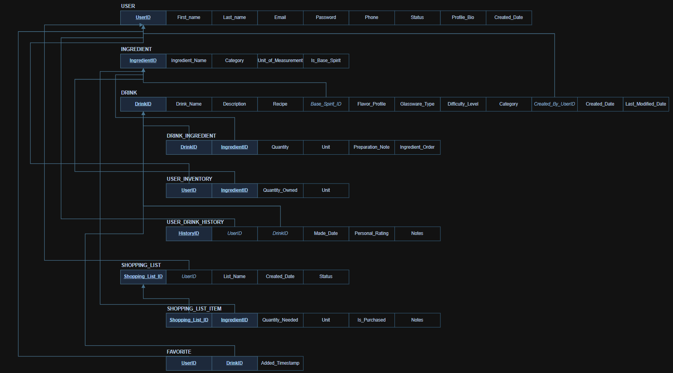

Roles of Project Members
Describe the role and contribution of each team member, including Generative AI.
Team Member 1: Griffin Witt
Role: Every member will contribute to every part of the project

Team Member 2: Louie Finder
Role: Every member will contribute to every part of the project

Team Member 3: Ryan Grant
Role: Every member will contribute to every part of the project

Team Member 4: Timur Bashpanov
Role: Every member will contribute to every part of the project

Generative AI:
Role: Correct Spelling, suggestions on certain approaches. We also used AI to document the changes made to our ER diagram when we converted it to a logical diagram. We had it formalize our explanations properly.

